RUGID GUARD SURVEY FORM
Date: _________________
Sold To:______________________________________________________________________________
Address: ______________________________City: _________________ State: _____ Zip Code: _______
Phone #:______________________ Fax#:___________________Email:___________________________
Site Name: ____________________________________________________________________________
Address: ______________________________City: _________________ State: _____ Zip Code: _______
Crossroad or Intersection of Site: __________________________________________________________
Manager’s Name: _____________________________ Store Phone#:_____________________________

Number of Gas Islands: _______ Number of Diesel Islands: _______
Gas Islands:
Gas Island 1 W x L: _________________ Gas Island 2 W X L: _________________ __________________
Gas Island 3 W x L: _________________ Gas Island 4 W x L: ___________________________________
Gas Island 5 W x L: __________________Gas Island 6 W x L: ____________________________________
Diesel Islands:
Diesel Island 1 W x L: ________________ Diesel Island 2 W x L: ________________________________
Diesel Island 3 W x L: _________________ Diesel Island 4 W x L: _____________________________
How many Built-in Bumpers per Island (**See Example C in the Sample Island Section of the Form):______________
How many U-Shaped Bumpers are on Site:________ How many do you want done in the Rugid Guard System:________
How many Straight Bollards are on Site:________How many do you want done in the Rugid Guard System:_________
*DRAW ALL U-BUMPERS AND BOLLARDS YOU WANT DONE IN THE SITE LAYOUT SECTION OF THE FORM
Store and Kiosk Curbing:
Total Linear Feet (Measure the Distance of Curbing all the way around the Store and or Kiosk):___________________
Additional Square Footage (Additional Concrete to be Coated in the Rugid Guard System):
Kiosk Island W x L:______________________ Kiosk Building W x L:____________________________
Store Sidewalk/Walkway (Around your Convenience Store) W x L:________________________________
Site Layout
DRAW A LAYOUT OF THE SITE, PLEASE INCLUDE ALL CURBING, DISPENSER ISLANDS, AND U-SHAPED BUMPERS

TAKE PICTURES!
TAKE PICTURES OF THE OVERALL SITE, CURBING AROUND STORE/KIOSK, DISPENSER ISLANDS, AND U-BUMPERS
Email Survey Form and Pictures to Rugidguardusa@gmail.com
Please Contact Tina Herschbach (618)477-1617 Therschbach@rugidguardusa.com for more Information

Sample of Islands

Measurements should include the total width (width =widest part of island) and the total length of the island (length= longest part of the island).
Example: A
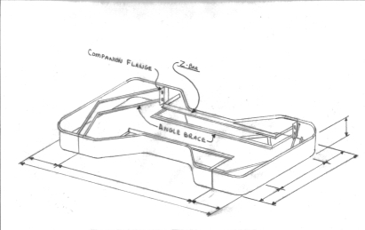
Example: B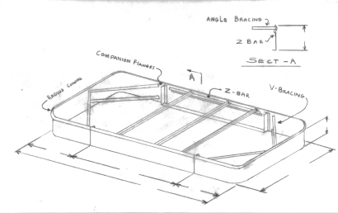

Example: C Island with built-in Bumpers
